**Country report – Lithuania**

**Section 1**

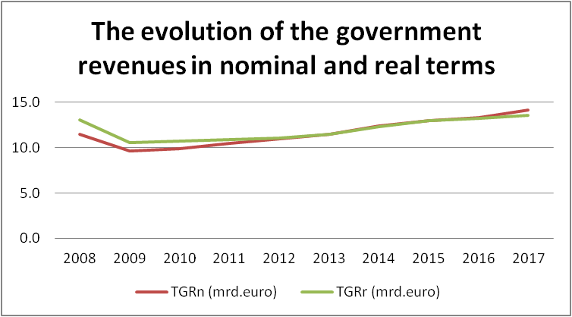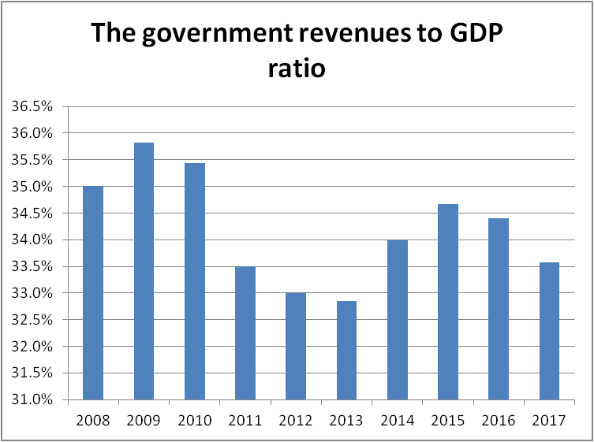

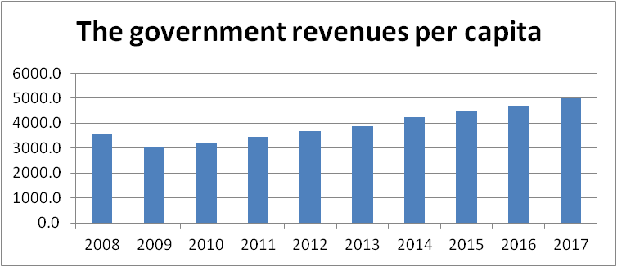

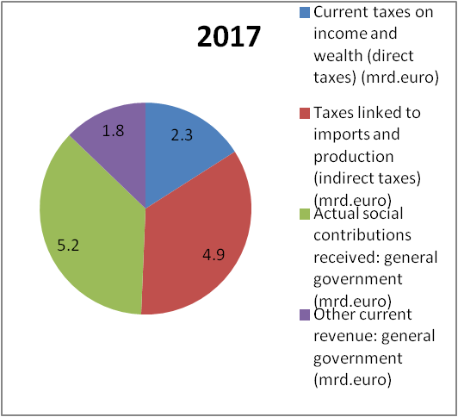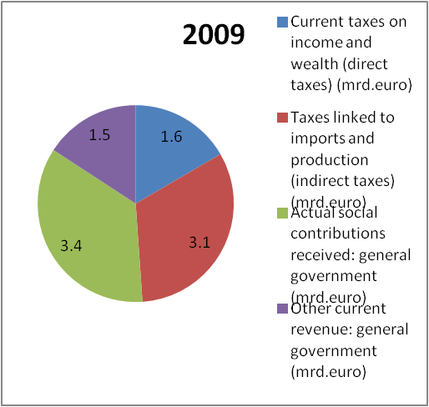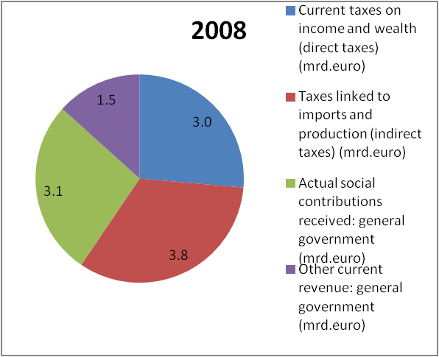



**Section 2**

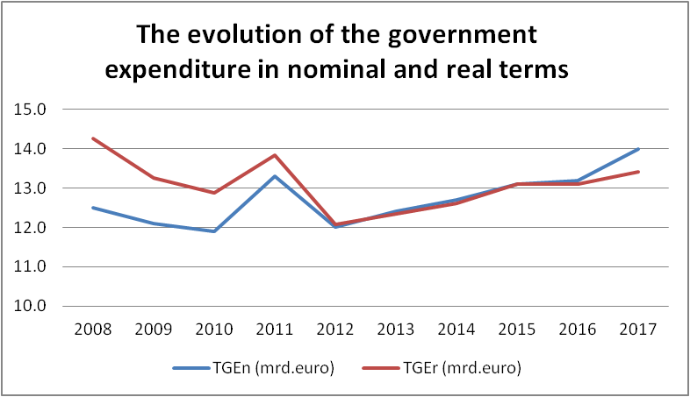

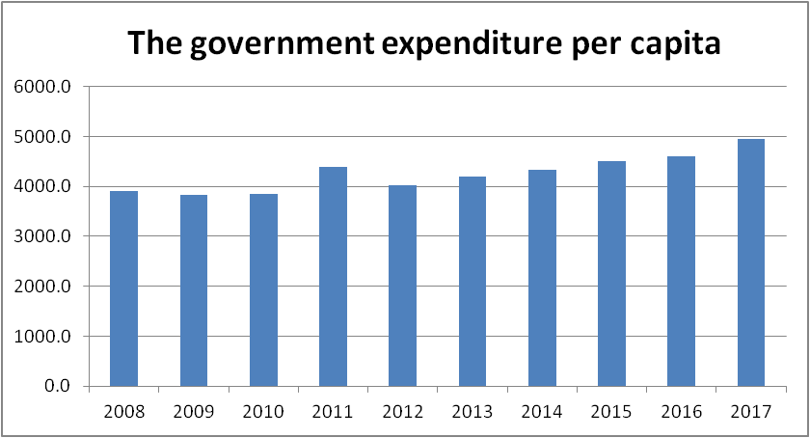

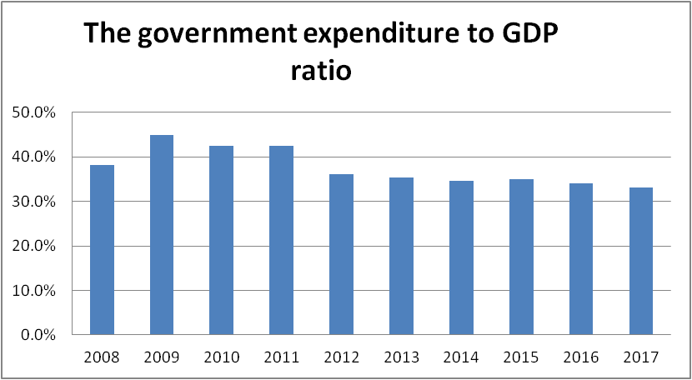

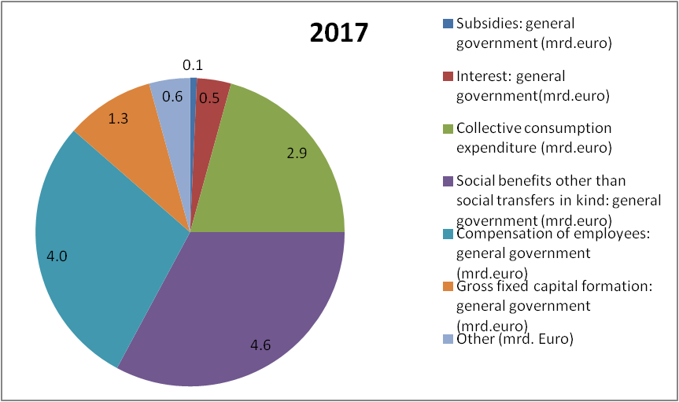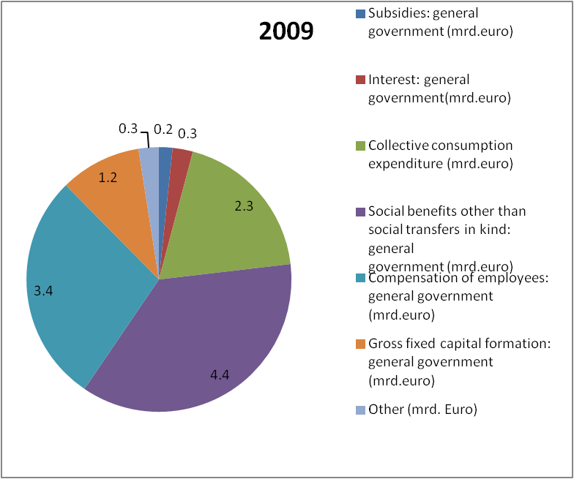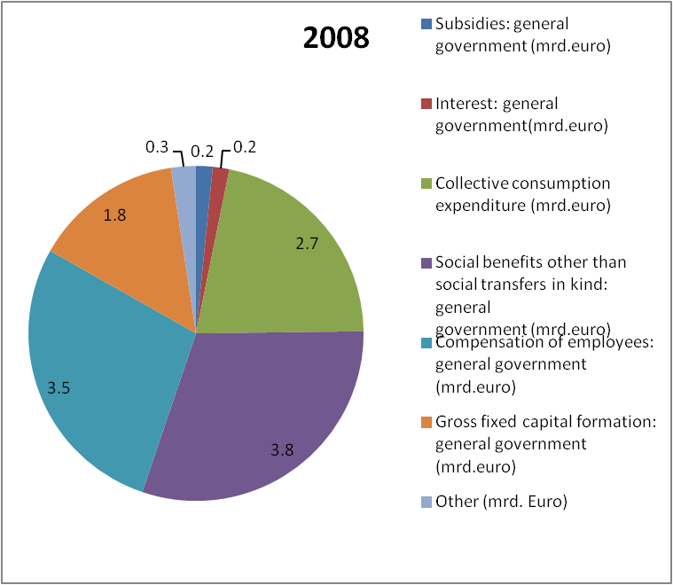

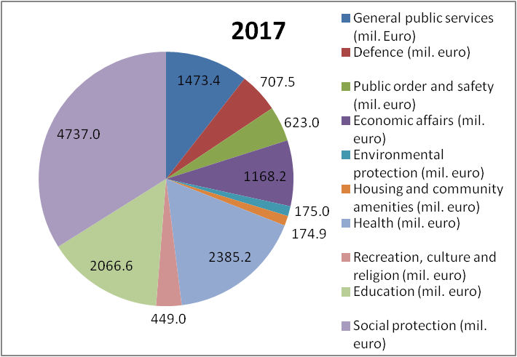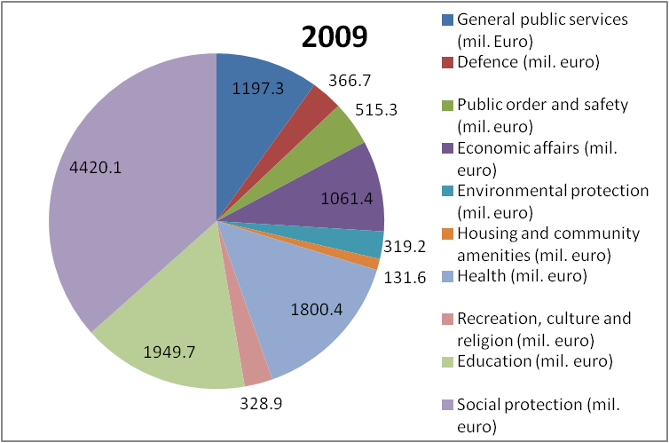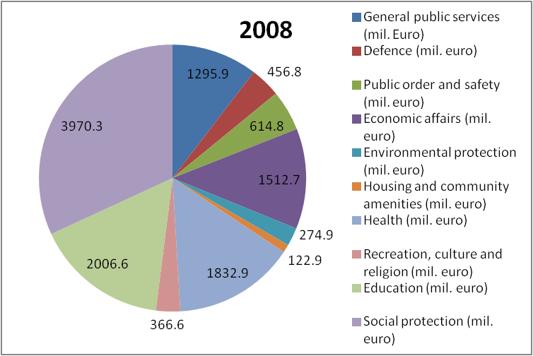



**Section 3**

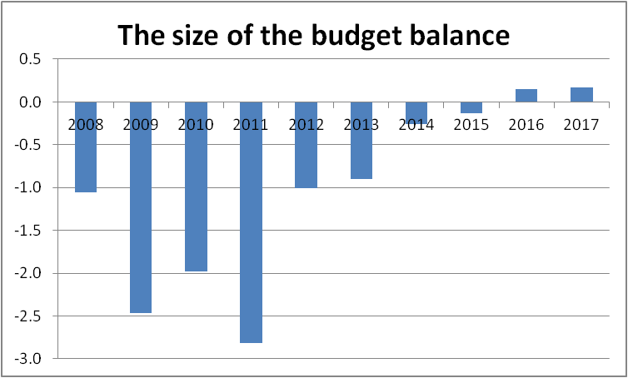



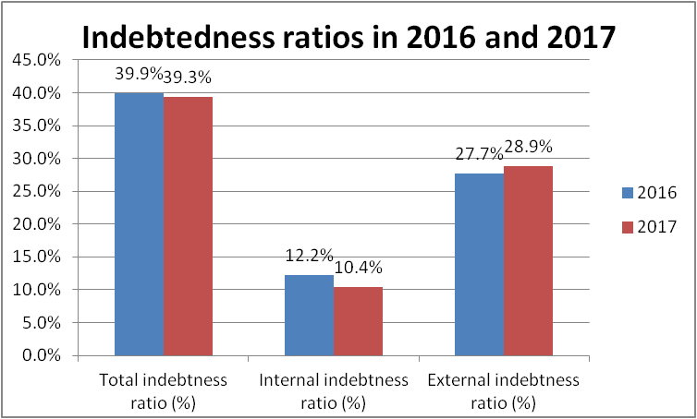



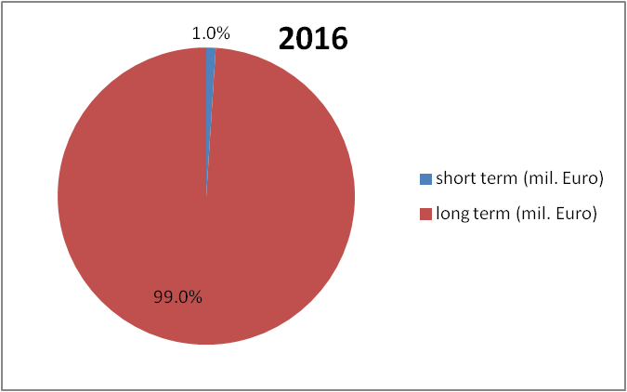

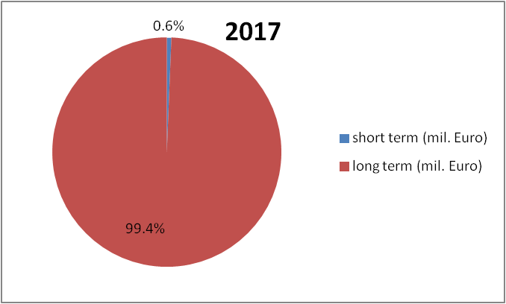



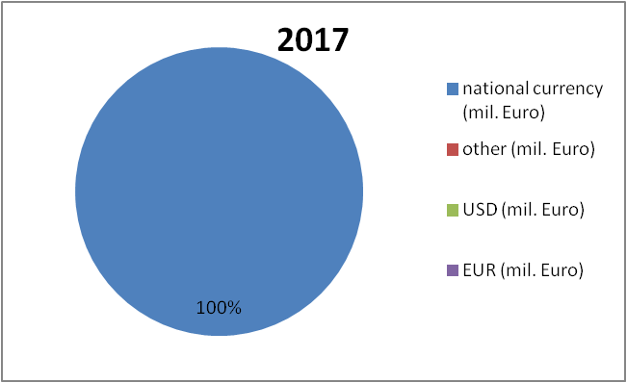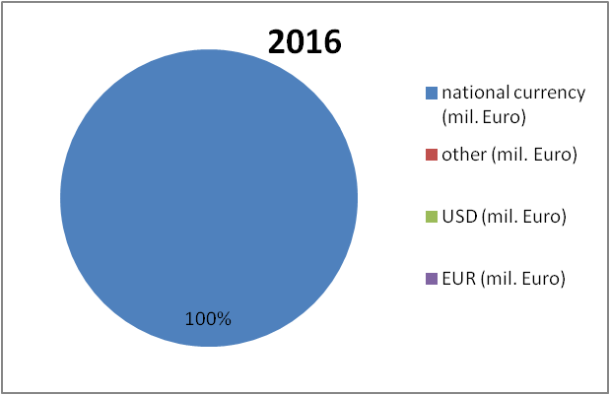

**Section 4**

Our analysis shows that over the last 10 years, there was an increase in TGR in nominal terms by 23.8%. This situation can be explained by several factors: the increase in prices throughout this period, the increase in the GDP and the growing rate of taxes. Comparing levels of government revenues, as a share of GDP or per capita, provides an indication of the importance of the public sector in the economy in terms of available financial resources. The total amount of revenues collected by government is determined by past and current political decisions. Regarding the composition of the government revenues, the most important part is represented by the social contributions (5.2 bn. Euro in 2017). The elasticity of TGR to GDP maintained below 1, but between 2014-2015, Lithuania experienced a period of elasticity, which means that the TGR increased much more than the GDP. In terms of expenses, general government spending, as a share of GDP and per person, provides an indication of the size of the government of Lithuania. It can be observed that over the last 10 years, the share of the TGE to GDP had a slowly increase, followed by a massive decrease between 2011-2012 (6,5%). The large variation in this indicator highlights the variety of country’s approaches to delivering public goods and services and providing social protection, not necessarily differences in resources spent. However, the government size was 33.2% in 2017, maybe because of the decrease in the country’s population, which had a decreasing tendency over those years. Similar to other states in the EU, the biggest part of the composition of government expenditure by economic function in Lithuania is represented by the social benefits (32,9% in 2017). This situation is reflected in the composition of government expenditure by government function, where social protection represents the biggest part, followed by health and education. In 2008, the budget balance entered a period of deficit that lasted 8 years, but managed to come out of it in 2016. However, the general government gross debt tripled over the last 10 years, showing that Lithuania is a country that needs some extra money in order to invest in its development. It is an indicator of an economy's health and a key factor for the sustainability of government finance.

BIBLIOGRAPHY

1. <http://ec.europa.eu/economy_finance/ameco/user/serie/SelectSerie.cfm>

2. <http://ec.europa.eu/economy_finance/ameco/user/serie/SelectSerie.cfm>

3. <https://en.wikipedia.org>

4. <https://data.oecd.org>

**TEAM:**

Plăpămaru Gabriela

Pletosu Maria

Popa Alexandru

Sandu Costin